AI ASSISTED CODING
LAB-13.2
NAME: MOHAMMED AREEBUDDIN
ENROLLNO:2403A52054
BATCH:03
TASK-01:
Remove Repetition.
PROMPT:
Refactor the following redundant code
def calculate_area(shape, x, y=0):
if shape == "rectangle":
return x * y
elif shape == "square":
return x * x
elif shape == "circle":
return 3.14 * x * x
CODE:
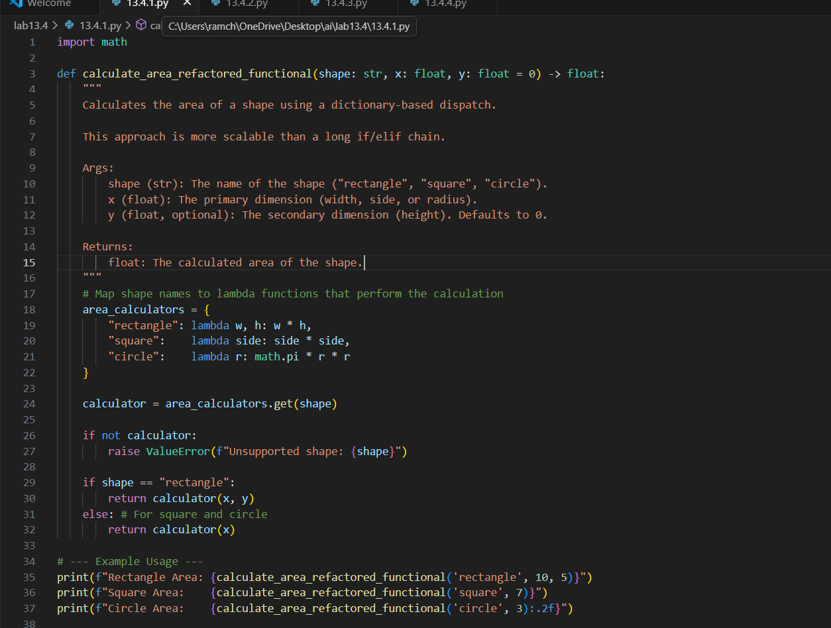
OUTPUT:
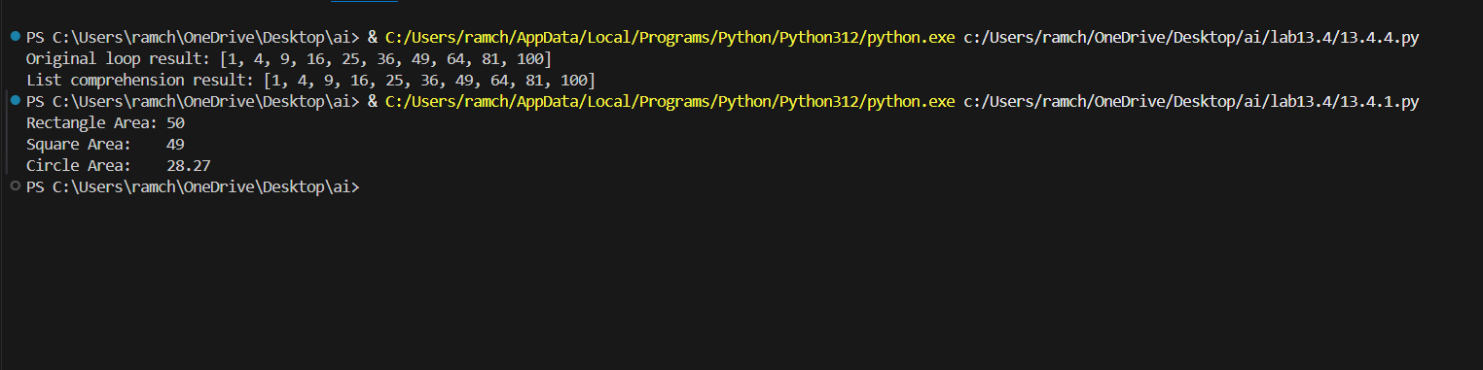
OBSERVATION:
The function calculate_area computes the area of a rectangle, square, or circle based on the given dimensions. It converts the shape name to lowercase for consistency, uses x as the main dimension and y as an optional width for rectangles, and calculates the area accordingly. For rectangles, both x and y are required, squares use x**2, and circles use math.pi * x**2. It raises an error if the shape is unknown or if required dimensions are missing. The docstring explains its usage and parameters.
TASK-02:
Error Handling in Legacy Code.
PROMPT:
The following python code that reads the file but it doesn’t handle the errors . rewrite the code by correcting all the errors.
def read_file(filename):
f = open(filename, "r")
data = f.read()
f.close()
return data
CODE:
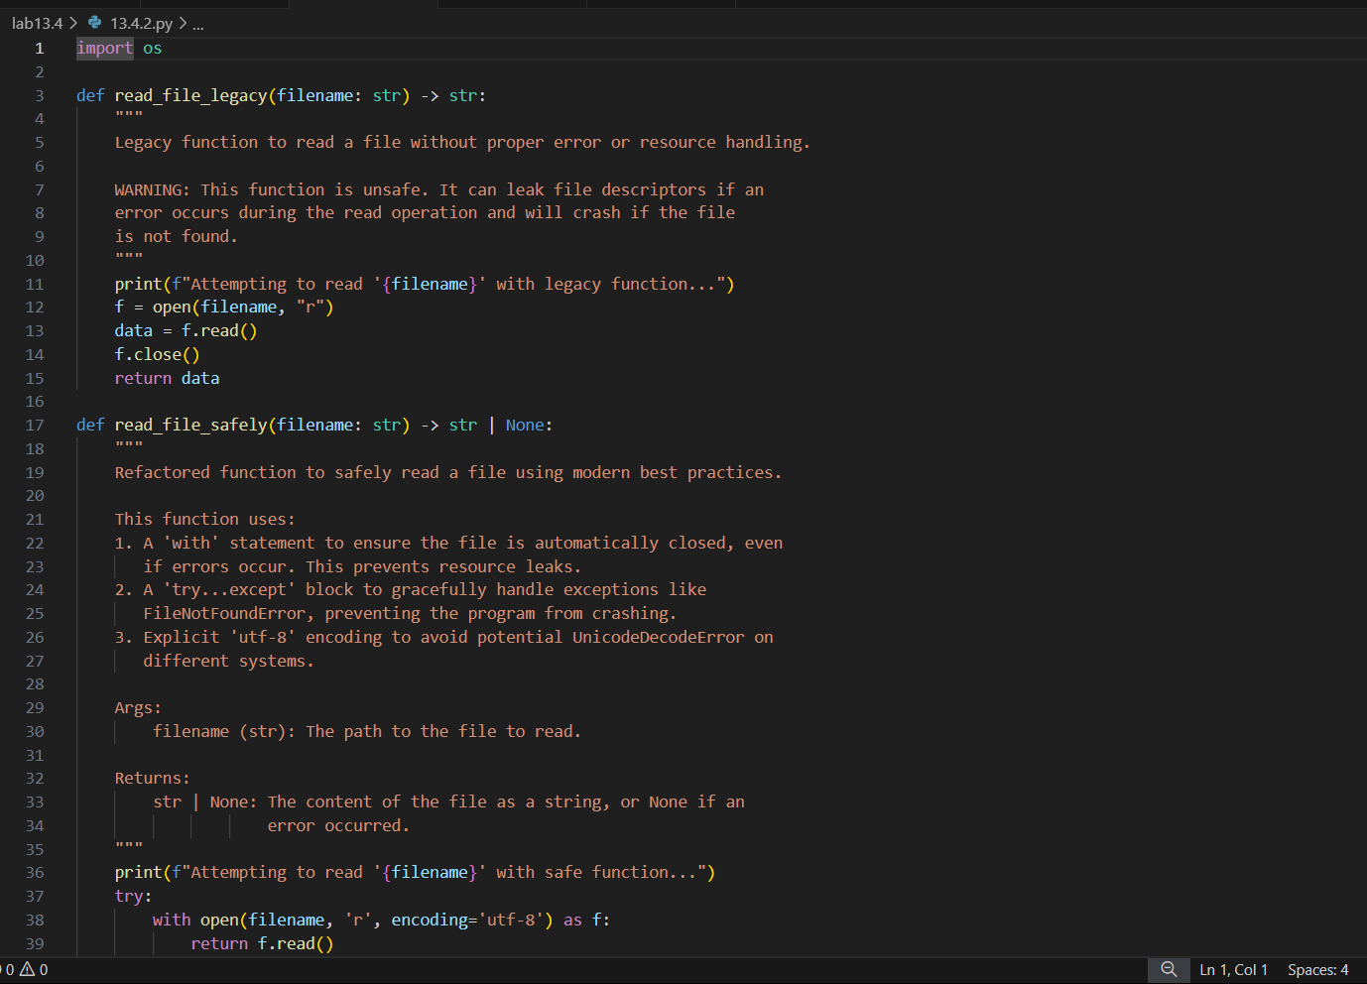
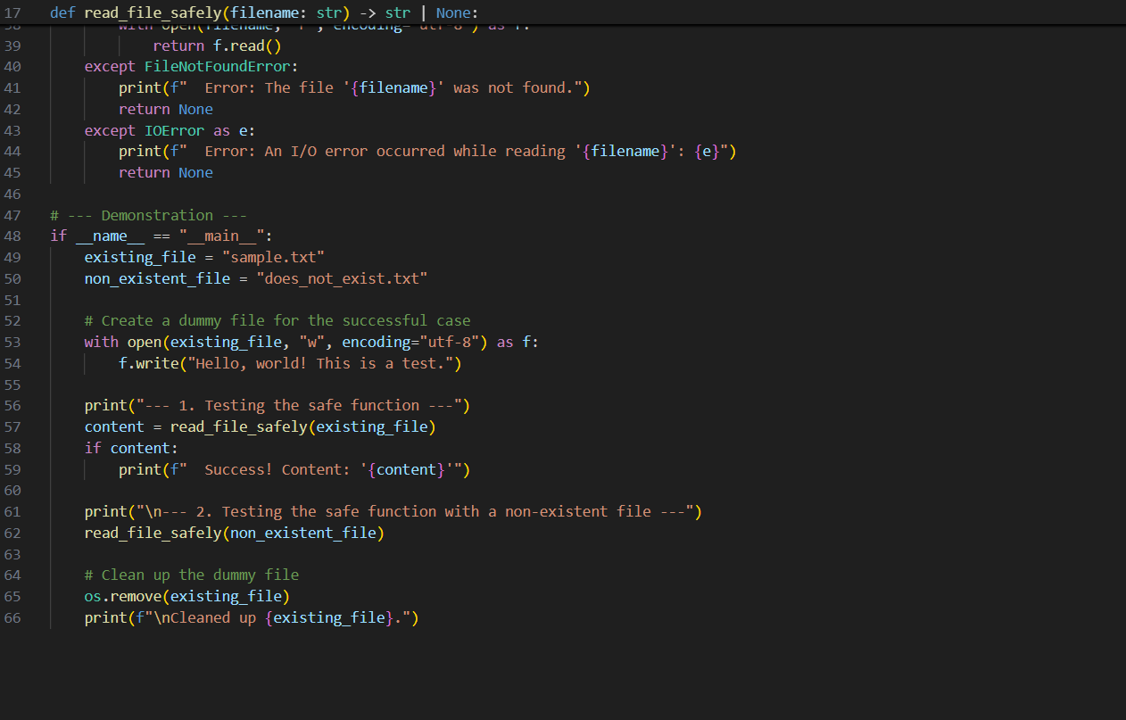
OUTPUT:
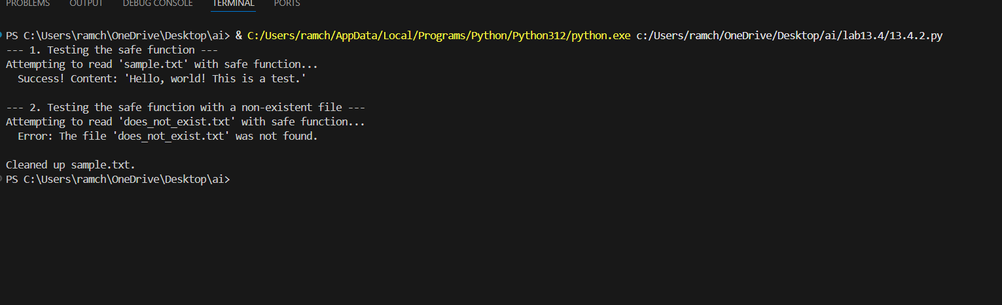
OBSERVATION:
The refactored function safely reads a file using with open(), ensuring the file is automatically closed, and uses try-except to handle errors like missing files or read failures. It provides clear error messages instead of crashing, making the code more robust and reliable.
TASK-03:
Complex refactoring
PROMPT:
Rewrite the following code by adding the proper variable names and refactor it in a proper way.
class Student:
def __init__(self, n, a, m1, m2, m3):
self.n = n
self.a = a
self.m1 = m1
self.m2 = m2
self.m3 = m3
def details(self):
print("Name:", self.n, "Age:", self.a)
def total(self):
return self.m1+self.m2+self.m3
CODE:
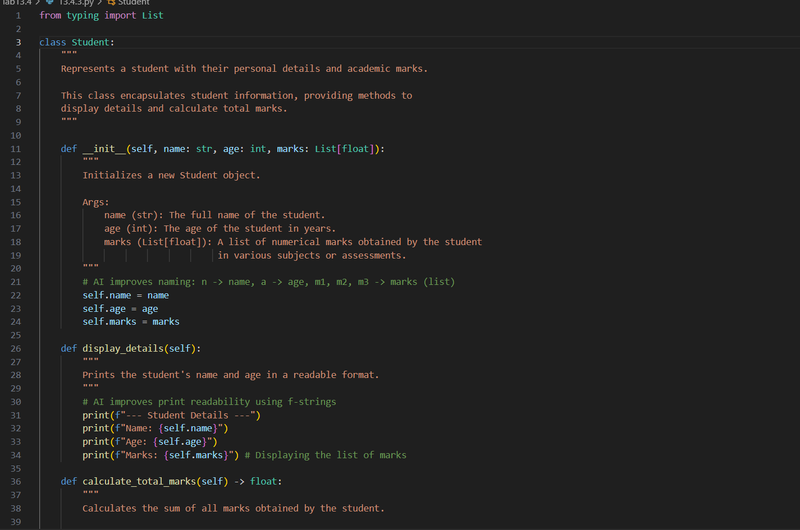
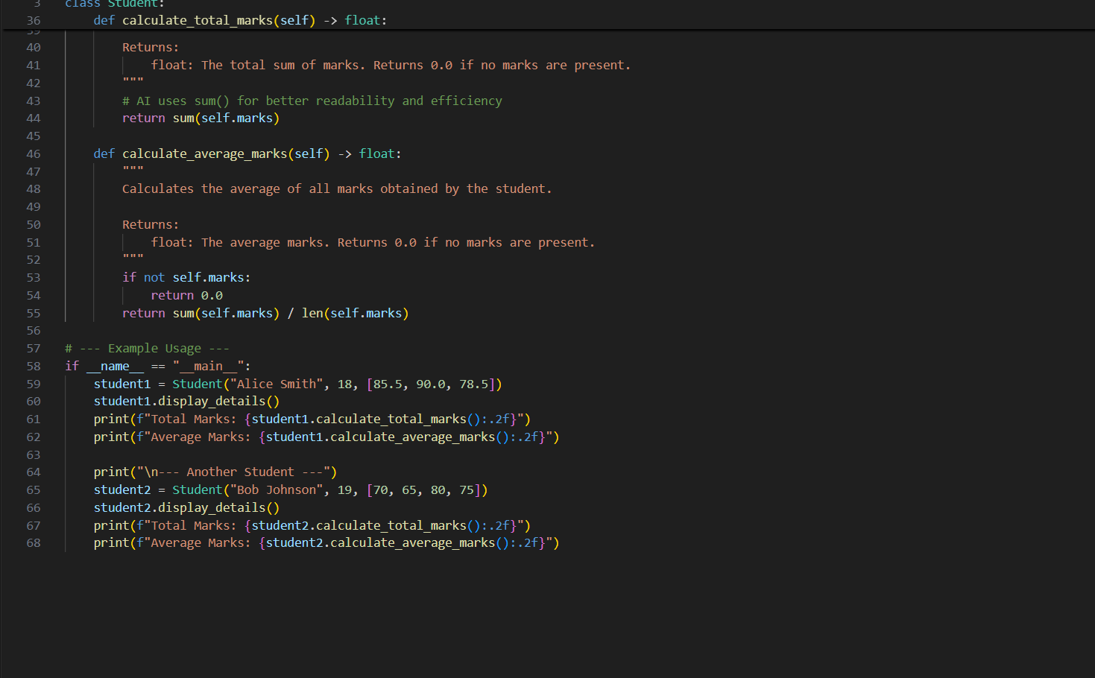
OUTPUT:
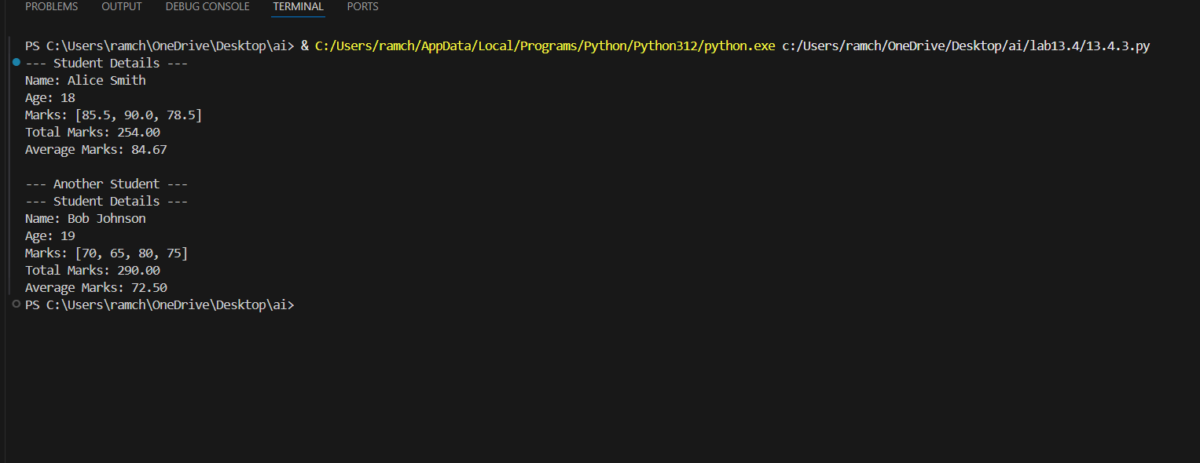
OBSERVATION:
The refactored Student class improves readability and modularity by using meaningful names, storing marks in a list, and adding docstrings. The details method prints information clearly with formatted strings, and total efficiently sums marks using sum(). The design is now more flexible and easier to extend.
TASK-04:
Inefficient Loop Refactoring
PROMPT:
I have a Python loop that computes squares of numbers and appends them to a list, but it seems inefficient. Can you rewrite it in a shorter, more Pythonic way and explain why it’s better?
nums = [1,2,3,4,5,6,7,8,9,10]
squares = []
for i in nums:
squares.append(i * i
CODE:
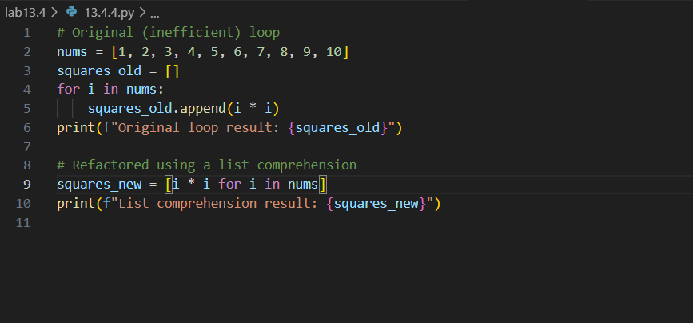
OUTPUT:
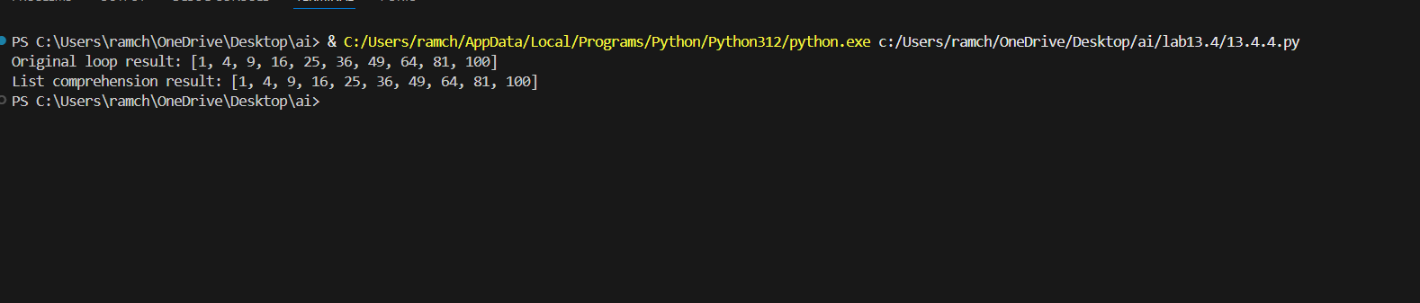
OBSERVATION:
The list comprehension makes the code shorter, more readable, and efficient by replacing the explicit loop and append() method with a single expression.

